Summary

WBR - Summary (for Pre-Read)
DLD Market
● Market continues it growth at 28%, driven by growth in both primary (+34%) and secondary (+21%) segments
Sales (UAE)
● Sales Forecast %: AED 63.5M forecast (100% of AED 63.5M target)
REMARK: NB offers approved by Jamie - Seal 100 offer (upto 100% bonus credits) for Tier 1 prospects and Seal 200 offer (upto 200% bonus credits for the top 20 clients with the highest exclusive listings)
Supply
● Net Exclusive Listings: 16.1K total (+4.4K WoW); Sale 12.8k (+4.1k WoW), Rent 3.3K (+0.3k WoW)
● Total Listings: 364K (+2% WoW); 29% gap with competition exists
ACTION: Conversation with ELT to align on
- Net Exclusive Listing Targets and Plan
- Discussion to also conclude PF’s stance on Duplicate listings & SERP adjustments
- View on Total Listings to be taken
New Projects
● Sessions: 83.1k weekly (vs 87k target); MtD 212.1k vs 385.5k target (-21.4% YoY)
● Sold Leads: 1,965 weekly (vs 1,787 target); MtD 4,912 vs 7,910 target (+132.9% YoY)
● Gross Revenue (USD): $162.1k weekly (vs $130.6k target); MtD $416.8k vs $578.2k target (+169.7% YoY). Expected to close the month 20% above revenue target.
Demand Section
- SEO SoV continues its growth and stands at 42.8% (+1.2pp vs previous week)
ACTION: Mahmoud to speak with Soumar and Nina and align on next steps for UGC Content
ACTION: Mahmoud to speak with Ashish and Hamed to structurally deep-dive on correlation
- Demand Data Challenges: Beyond the existing data challenges on SEO & Unpaid-Direct Sessions (spam issues),
This week App Sessions and Leads saw an issue due to Kochava on 15th and 18th of Jan (missing data, untagged data)
This has a downstream impact on LPL calculations as well
ACTION: Khaled to resolve issues with Kochava via short term fixes
- Web Unpaid Funnel: Is moving closer to target and is ~1% lesser than target (Sessions 511k vs 512k Target, Leads 68k vs 69k target and Conversion rate is 13.3% vs 13.5% target)
ACTION: On Exposure LPL - Set up a small group conversation with Soumar, Ahmed and Paresh
B2C App Engagement
- App Installs: Moving closer to the targets, as installs are at 22k vs target of 22.5k (-2%)
- Ratings: Playstore (4.5) and appstore (4.7) ratings have met targets
B2C Tech
● Core Web Vitals: 2 out of 6 core web vitals are under performing (INP Mobile and Desktop)
- Appdex Score iOS: Under 95% threshold
ACTION: BA to revisit the calculation method for iOS Appdex score
- Appdex score Android: Above the 95% threshold
B2B Product
● P0 Incidents: 4 weekly (vs 1.3 target); MtD 3 vs 6 target
● P1 Incidents: 17 weekly (vs 17 target); MtD 34 vs 68 target
● B2B App Active Agents: 9,705 (-34 vs 9,739 target); +408 vs 2 weeks prior
● B2B WAU (Active Users per Week): 3,167 (+167 vs 3,000 target); +609 vs 2 weeks prior
Listing Quality
● Compliance %: 97% (vs 87% target)
ACTION: Saif to speak with B2C and finalize the way forward on duplication SERP adjustment
● Availability Perception: 80.9% MtD (vs 79% target); +7.1pp YoY
● Listing Quality Score: 93.6% MtD (vs 93% target); +2.7pp YoY

DLD Market Growth

Property Finder
Weekly Business Review

Market (Dubai)
- DLD market continues its growth, with both Primary (+34% YoY) and secondary (+21% YoY) picking up momentum

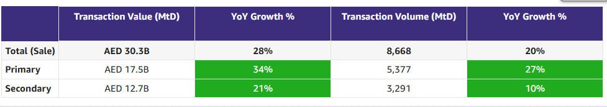

Commercial

Commercial
Category | DRI | Which metric is red and why | Actions planned | ETA for target achievement
Sales forecast % | Vladimir Malugin | - January sales forecast is at 100.2% MTD, primarily driven by Dubai Diamond, Dubai Ruby and First Year, with Abu Dhabi and Northern Emirates also performing above 100% MTD | Continued focus on increasing sales through the following actions:  - Account Plans  - Launch of 5 new offers focused on New Business, PF Edge, Exclusive Listings & 100% Growth (LIVE)  - Strong partnership with Commercial Analytics to build clear renewal narratives for key Diamond and Ruby accounts  - Extension of Q4 offers into Q1’26 (LIVE)  - Resegmentation and sub-segmentation (now stabilised) | - On track
Client level Exclusive listing | Prateek Goel | - Wow Increase of +4.4K due to the following:  - Bayut-only clients reduced their listings by 1.4K (major contributions being h m i real estate l.l.c and azco - business bay)  - Within common clients, top 5 clients drove >80% of the impact on exclusive listings through reduction in BY exclusives | - Edge launched across all segments and territories in the UAE  - Working on SPIFF for NB team  - Working with product team on focused initiatives to decrease Bayut exclusive listings & increase PF exclusive listings  - Bulk upload  - SuperAgent points: Direction is to proceed with weekly scraped data  - Milestone driven benefits: Proposal in progress | - [...]

Weekly Metrics
 |  | Weekly |  |  |  | MTD
Category | Metric | Week  (Actual) | Week (Target) | WoW | vs 2 weeks prior | MtD  (Forecast) | Month (Target) | vs MtD  prev month (MoM) | vs MtD  prev year (YoY) | vs competition | DRI | Dash
Sales  (MtD) - UAE | Sales Forecast %  (Month-end) | Monthly -> |  |  |  | 63.6M  (100.2%) | 63.5M | Not Applicable | Not Applicable | Not Applicable | Vladimir Malugin | Link
Supply | Net Exclusive Listings | 16.1K | NA | +4.4K | +3.6K | NA | <Monthly> | NA | NA | Not Applicable | Prateek Goel
 | Total Listings | 364k | NA | +2% | +3% | NA | NA | NA | NA | -29%  510k
 | Dubai | 209k | NA | +2% | +2% | NA | NA | NA | NA | -7%  225k
 | Abu Dhabi | 15.7k | NA | +7% | +10% | NA | NA | NA | NA | +20%  13.1k
 | Northern Emirates (incl Al Ain) | 139k | NA | +2% | +4% | NA | NA | NA | NA | -49%  272k

Category | Metric | Week  (Actual) | Week (Target) | WoW | vs 2 weeks prior | MtD  (Actual) | Month  (Target) | vs MtD  prev month (MoM) | vs MtD  prev year (YoY) | vs competition | DRI | Dash
Net exclusive listings | Rent | 3.3K | NA | +0.3k | -0.2k | NA | NA | NA | NA | Not Applicable | Prateek Goel
 | Sale | 12.8k | NA | +4.1k | +3.8k | NA | NA | NA | NA | Not Applicable | Prateek Goel

Demand (Paid/Unpaid)

Demand
Category | DRI | Which metric is red and why | Actions planned | ETA for target achievement
Paid | Ahmed Osman | - Web Paid Sessions: WoW Recovery, we expect to close the 4% MtD gap before the end of the month.  - Total App Sessions/Leads: Drastically lower WoW because of a data incident affecting iOS metrics (on the 15th of Jan). | - As campaigns scale, we expect to close the gap before the month's end.  - The data issue is being worked on by DE. An escalation to Kochava was raised. Fixes for row limits, backfill testing, and platform review are being explored. | - The monthly target will be achieved across sessions and leads. Expecting a 1.5 p.p gap in CR%
Unpaid - SEO | Mahmoud Nessim | - SEO SoV is improving WoW: We’ve seen some significant movements on the SoV on daily, reaching a peak of 46.2% which is all time high since 25’ drop, however SEMrush have data issues, which is currently being fixed, along with we’ve also fluctuated back to ~ 40s in the SoV  - The Growth is purely driven by fat tail keywords in the SERPs & Community related Keywords complemented by our recent efforts with the content prioritization and creation  - The forecast for jan based on MTD, is showing a 111% monthly target achievement, on the Google search console clicks. | - The growth is healthy, but still we’re targeting to go above and beyond, to stabilise these movements with higher positions, we need to push it more with refreshed content which is the UGC, we’ve it planned for PLPs, SERPs, Community insights and new projects to surface the buildings and communities reviews,  - In order to strengthen our positioning in the market we’re also focusing on the gap in Arabic which is showing some steady movements, where we’re focusing to ship the translation logic on the PLP description as a start,  - We’ve revamped the content in the footer to make it more data rich and goes with the SERP revamp | - SERP Revamp by mid Feb,  - PLP UGC by end of Jan  - SERPs UGC by mid Feb,  - PLP Translation by End of Jan.
Unpaid - Overall | Soumar Aoun | - No formal metrics to report yet on unpaid web (spam to be removed by 24th Feb)  - App conversion rates are green, while app sessions are currently red. We have multiple concrete levers already in execution to address this:  - (a) Android re-engagement unlock (ETA: EONW)  We identified a Tealium logic issue that has been limiting the volume of re-engagement traffic we can send on Android. This is actively being fixed and will unlock suppressed sessions once resolved. | - (b) Post-lead re-engagement (ETA: live by end of this week)  We are launching a post-lead re-engagement strategy targeting users who have already created at least one lead, with the goal of driving their second and subsequent leads.  Users will receive highly relevant property recommendations based on the lead they submitted.  - (c) Investor-intent activation for New Projects (ETA: live by end of this week)  We now have investor intent signals, enabling us to re-engage this cohort with relevant New Projects inventory, unlocking a new high-value session and lead stream.  - (d) Dormant user re-engagement (100% launch yesterday)- 2.5 x increase in open rate (data for sessions isn’t flowing through). We are launching push notifications to dormant users with relevant new listings. | - January is execution-heavy and focused on driving sessions and leads, with work kicking off across SERP revamp, Web PLP revamp, Homepage revamp on both App and Web, AI UI uplifts, missing filters, and CRM-driven initiatives. In total, we’re running around 10 initiatives this month, all aligned to strengthening discovery, engagement, and downstream conversion.

Competition:
1. SoV - Paid click share
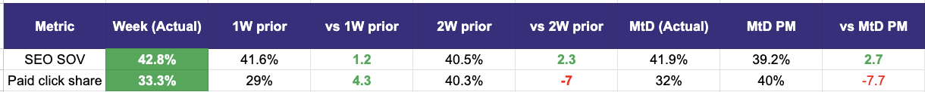

2. Demand Funnel (Direct and SEO Data are currently being fixed under Data Governance Workstream)
Web - Paid
App (Paid + Unpaid)

Exposure LPL
(EXCLUDES DIRECT)
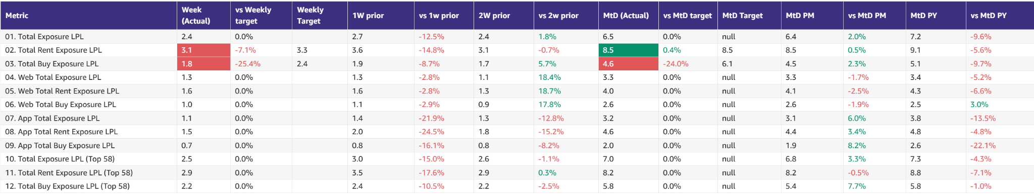

Leads and Listings distribution

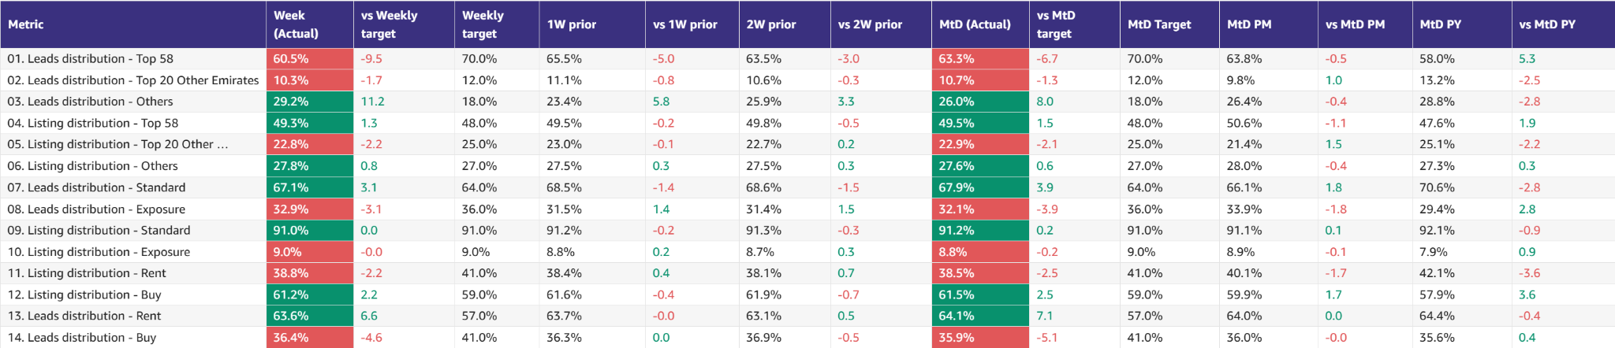

Rent vs Buy Split

Monthly Metrics

B2C NPS
Category | Metric | MtD  (Actual) | Month (Target) | vs MtD  prev month (MoM) | vs MtD  prev year (YoY) | vs competition | DRI | Dash
B2C NPS | B2C NPS |  | Not Available |  |  | Not Available | Alson Dsouza

PR Metric
Category | Metric | MtD  (Actual) | Month (Target) | vs MtD  prev month (MoM) | vs MtD  prev year (YoY) | vs competition | DRI | Dash
PR | PR Sov | 71% | 50-55% |  |  | 26.1% (Bayut) and 2.9% (Dubizzle) | Natalie Faulkner | PR team

Leads click to delivered:
Category | Metric | MtD  (Actual) | Month (Target) | vs MtD  prev month (MoM) | vs MtD  prev year (YoY) | Δ vs Competition | DRI | Dash
Leads Funnel | Total Leads Delivered (WA) |  |  |  |  | Not Available | Olivia Watters | Link
 | % Clicks to Delivered (WA) |  |  |  |  | Not Available | Olivia Watters | Link
 | Error Leads (WA) |  |  |  |  | Not Available | Olivia Watters | Link

DATA GOVERNANCE
Data Issue | Latest update | Resolution update (ETA) | DRI
Spam Issues | CHEQ implementation across tools in progress | Current & past data resolution by 24th Feb | Ram Moorthy
SEO (Sessions vs clicks) | Under last-touch attribution, repeat or direct returns get credited to SEO, so SEO sessions appear higher than GSC clicks. | Findings & conclusions by tomorrow  Next steps to be finalized with Volkan, Mahmoud | Ram Moorthy  Volkan Oktem
CRM Attribution | Implementation is complete; validation is pending confirmation Abhay Mahajan | 7th feb(tentative) | Abhay Mahajan

- Competition
  - Share of Session (Overall, Web Channels, App Channels)
  - SoV - Paid click share

- Demand Funnel
  - Sessions (by channels)
  - Leads (by channels)
  - CR (by channels)
  - Click to Delivered

- Exposure LPL
  - Overall / Rent / Sale
  - Top Communities
  - Web/App
  - Exposure Leads as % of Total Leads (Overall / rent / sale)
  - Exposure Listings (Overall / rent / sale)

- Engagement Metric (Time on site)
- B2C NPS
- PR SoV
- Leads split by Rent vs Buy

B2C App Engagement

B2C App
Category | DRI | Which metric is red and why | Actions planned | ETA for target achievement
App engagement & installs | Ahmed Osman | - Installs slightly below target as we calibrate our budgets in line with 2026 spending targets | - N/A, we expect an improvement to the run rate as we go. | - The monthly target will be achieved.
App ratings | Soumar Aoun | - App ratings in green | - N/A | - -

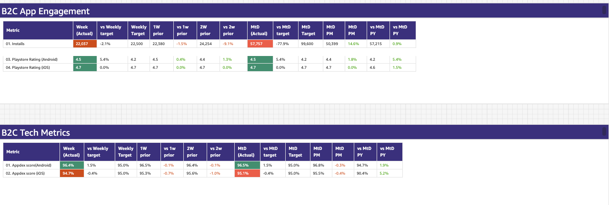


Weekly Metrics -
- App Installs
- App MAU
- DAU/MAU
- Sessions / DAU
- Login Ratio
- Avg Session Duration
- Playstore rating (Android)
- Playstore rating (iOS)

B2C Tech Metrics

B2C App
Category | DRI | Which metric is red and why | Actions planned | ETA for target achievement
App stability & performance | Taran Kambow | - [...] | - [...] | - [...]
Web Stability & Performance | Amory Kelie | - Desktop healthy; mobile INP below threshold on listing pages | - Validate mobile INP drivers on high-traffic listing pages  - Prioritise INP improvements within near-term SEO initiatives  - Track CWV impact via Search Console as part of SEO performance reviews | - Q2 or Q3



 |  | Weekly |  |  |  | MTD
Category | Metric | Week  (Actual) | Week (Target) | WoW | vs 2 weeks prior | MtD  (Forecast) | Month (Target) | vs MtD  prev month (MoM) | vs MtD  prev year (YoY) | vs competition | DRI | Dash
Tech stability & Performance | CWV % URLs rated “Good” | Mobile: 36% | Desktop: 68% | Mobile 50% | - | - | NA | NA | NA | NA | NA | Amory Kelie

- Appdex: Android
- Appdex score: iOS
- Core Web Vitals

B2B Product

B2B
Category | DRI | Which metric is red and why | Actions planned | ETA for target achievement
CSAT (P0s) | Luis Cappa | Last week we received 4 P0s and 17 P1s across all 5 x B2B Teams. While we missed our weekly target, we remain green against our monthly targets of 6 P0s and 73 P1s across the five teams involved.  Three of the P0s were in Monetisation. Two shared the same root cause, an outage in RabbitMQ, which caused mismatches in credit allocation and deduction and temporarily prevented customers from publishing listings. The third Monetisation P0 was caused by a rare race condition where rapid successive updates on a listing led to an unstable state and blocked further updates. The fourth P0 was related to Compliance and was caused by a missing listing permit number. | We are slowly landing to a stabilization-flat volume of incidents that we target to reduce QoQ:  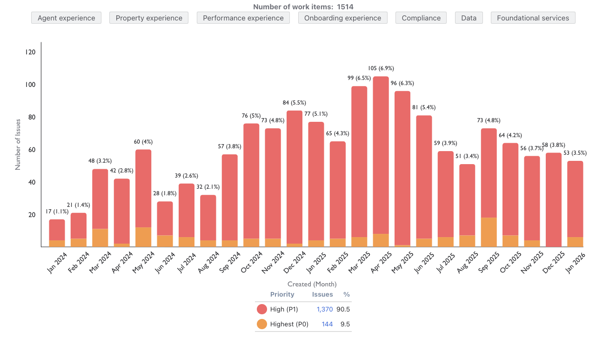 | End of Q1:  - P0s: 17  - P1s: 202
Agent Experience | Sajjad Ahmad | Falling short by 34 new users. Broadly green and on track,  - Average DAU ~1500  - New users joining /day ~30  - Week 4 is positive against targets | - The recently launched Owner Report feature is currently under GTM. | - On track for positive Jan exit

Weekly Metrics
 |  | Weekly |  |  |  | MTD
Category | Metric | Week  (Actual) | Week (Target) | WoW | vs 2 weeks prior | MtD  (Actual) | Month (Target) | vs MtD  prev month (MoM) | vs MtD  prev year (YoY) | vs competition | DRI | Dash
CSAT | Incident Volume | P0: 4  P1: 17 | P0: 1.3  P1: 17 | P0: 300% (0)  P1: 58% (12) | P0: +4 Wow (0)  P0: +21.4% (+14) | P0: 4  P1: 31 | P0: 6  P1: 73 | P0: +300% (0)  P1: -3% (35) | P0:200% (1)  P1: -32% (50) | Not Available | Luis Cappa | Link  (JIRA)
Agent Engagement & Experience | App active agents | 9705 | -34  (vs 9739) | +238  (vs 9467) | +408  (vs 9297) |  |  |  | Not Available | Not Available | Sajjad Ahmad | TBA
 | Active users per week (WAU) | 3167 | +167  (vs 3000) | +108  (vs 3059) | +609  (vs 2558) |  |  |  | Not Available | Not Available | Sajjad Ahmad | TBA
 | Agent NPS | NA | NA | NA | NA | Monthly Metric |  |  |  |  | Sajjad Ahmad | TBA

Listing Quality

Monetization
Category | DRI | Which metric is red and why | Actions planned | ETA for target achievement
Compliance | Saif Al-Amid | - Metric is stable at 97% - the Bayut dashboard is live showing difference in duplicated listings between bayut (20%) vs PF (9%) | - Alignment with ELT (specifically Ozan): Company is prioritizing unique/exclusive listings over total supply volume. Consequently, duplicate listings are acceptable, provided we optimize our SERP ranking to prioritize the best results for the end user. | - Saif to align with B2C at the end of this week regarding SERP ranking for duplicates.
Availability perception | Shradha Mohanan | - <monthly> | - <monthly> | - <monthly>
Listing quality | Huguette Bukasa | - <monthly> | - <monthly> | - <monthly>

 |  | Weekly |  |  |  | MTD
Category | Metric | Week  (Actual) | Week (Target) | WoW | vs 2 weeks prior | MtD  (Actual) | Month (Target) | vs MtD  prev month (MoM) | vs MtD  prev year (YoY) | vs competition | DRI | Dash
Listing Quality | Compliance % | 97% | 87% | -  (was 97%) | Not Applicable | Not Applicable | Not Applicable | Not Applicable | Not Applicable | Not Applicable | Saif Al-Amid | Link
Listing Quality | Availability Perception (%) | Not Applicable | Not Applicable | Not Applicable | Not Applicable | 80.9% | 79% | +1.2pp  (was 79.7%) | +7.1pp  (was 73.8%) | Not Applicable | Shradha Mohanan | Link
Perceived Quality | Listing Quality Score | Not Applicable | Not Applicable | Not Applicable | Not Applicable | 93.6% | 93% | +0.3pp  (was 93.3%) | +2.7pp  (was 90.9%) | Not Applicable | Huguette Bukasa | Link

Primary (NP, Media, Dev)

Primary (New Projects, Media Sales)
Category | DRI | Which metric is red and why | Actions planned | ETA for target achievement
New Projects | Enguerran Milhiet | - Similar story as previous weeks. | - Continue to deliver on our roadmap. | - Expected to close the month 20% above revenue target.
Media & Developers | Sami Awada | - NA | - NA | - NA

 |  | Weekly |  |  |  | MTD
Category | Metric | Week  (Actual) | Week (Target) | WoW | vs 2 weeks prior | MtD  (Actual) | Month  (Target) | vs MtD  prev month (MoM) | vs MtD  prev year (YoY) | vs competition | DRI | Dash
New Projects | Sessions | 83.1k | 87k | -2.8%  (was 85.5k) | +8.2%  (was 76.8k) | 212.1k | 385.5k | +10.9%  (was 191.2k) | -21.4%  (was 269.9k) |  | Enguerran Milhiet
 | Sold Leads | 1,965 | 1,787 | -5.3%  (was 2,076) | +25.6%  (was 1,565) | 4,912 | 7,910 | +5.1%  (was 4,675) | +132.9%  (was 2,109) |  | Enguerran Milhiet
 | Gross Revenue (USD) | $162.1k | $130.6k | -11.5%  (was $183.2k) | +15.7%  (was $140.1k) | $416.8k | $578.2k | -3.7%  (was $432.6k) | +169.7%  (was $154.5k) |  | Enguerran Milhiet
Media & Developer | Revenue from Media Products | NA | NA | NA | NA | Monthly |  |  |  |  | Sami Awada

Special Projects
Monthly Lookbacks

Special Projects - Q1 OKRs
Category | DRI | Status | Actions taken in the month | Plan forward / support required
Keyper | Soumar Aoun | Status
Packs | Paresh Goyal | Status
Converting at risk clients to Promoters | Mike AmourPascal Warnebold | Status

North Stars

 |  | Weekly |  |  |  | Month
Category | Metric | Week  (Actual) | Week (Target) | WoW | vs 2 weeks prior | MtD  (Actual) | Month  (Target) | vs MtD  prev month (MoM) | vs MtD  prev year (YoY) | DRI
Output metric | Share of Wallet | NA | NA | NA | NA
North Star Metric | Share of Sessions | NA | NA | NA | NA
North Star Metric | Net Exclusive Listings
North Star Metric | Exposure LPL (Sale)
North Star Metric | Exposure LPL (Rent)

📋 Prev Saved Reports

Week | Date | Link
Week 2 | Jan 5 to Jan 11 | WBR - Week 2 (SAVED) Metric Report
Year End.
W52 | Dec 1 to Dec 30 | WBR Metric Report - Dec Monthly Lookback (Saved Report)
W49 | Dec 1 to Dec 7 | WBR Metric Report - Week 49 (Saved Report)
W48 | Nov 1 to Nov 30 | WBR Metric Report - Week 48 - Nov Monthly Lookback (Saved Report)
W47 | Nov 17 to Nov 23 | WBR Metric Report - Week 47 (Saved Report)
W46 | Nov 10 to Nov 16 | WBR Metric Report - Week 46 (Saved Report)
W45 | Nov 3 to Nov 9 | WBR Metric Report - Week 45 (Saved Report)
W44 | NA | NA
W43 | Oct 1 to Oct 31 | WBR Metric Report - Week 43 - Oct Monthly Lookback (Saved Report))
W42 | Oct 15 to Oct 21 | WBR Metric Report - Week 42 (Saved Report)
W41 | Oct 8 to Oct 14 | WBR Metric Report - Week 41 (Saved Report)
W40 | Oct 1 to Oct 7 | WBR Metric Report - Week 40 (Saved Report)
W39 | Sep 1 to Sep 30 | WBR Metric Report - Week 39 (Saved Report)
W38 | Sep 17 to Sep 23 | WBR 2.0 Report - Week 38 (Saved Report)
W37 | Sep 10 to Sep 16 | WBR 2.0 Report - Week 37 (Saved Report)
W36 | Sep 3 to Sep 9 | WBR 2.0 Report - Week 36
W35 | Aug 1 to Aug 31 | Copy of WBR 2.0 Report - Week 35.docx
W34 | Aug 20 to Aug 26 | Copy of WBR 2.0 Report - Week 34.docx
W33 | Aug 13 to Aug 19 | WBR 2.0 Report - Week 33.docx
W32 | Aug 6 to Aug 12 | Copy of WBR 2.0 Report - Week 32.docx
W31 | Jul 30 to Aug 5 | WBR 2.0 Report - Week 31.docx

